LIBRARIES' ROLE IN MENTAL HEALTH LITERACY AT CHUKWUEMEKA ODUMEGWU OJUKWU UNIVERSITY, IGBARIAM CAMPUS
By

Ozioma Ezeibe Ebuka
Library Technologist
Chukwuemeka Odumegwu Ojukwu University, Igbariam
Anambra State, Nigeria.
Email: oe.ezeibe@coou.edu.ng
Phone: 08167331708
&
Amaka Alumona PhD.
Lecturer
Chukwuemeka Odumegwu Ojukwu, University Igbariam
Anambra State, Nigeria.
Email: amakaijeoma865@gmail.com
Phone: 08167167768

ABSTRACT
Objectives—This study examined the role of libraries in supporting mental health literacy among students at Chukwuemeka Odumegwu Ojukwu University, Igbariam campus. It focused on identifying mental health literacy needs, assessing impacts on academic performance and well-being, and making recommendations.
Method: A descriptive survey design was used. Data was collected from 60 postgraduate and undergraduate students using structured questionnaires, with a 93.3% response rate. The data analysis involved frequency and percentage ratings.
Results: Results showed a strong relationship between mental health literacy and academic performance. Many students lacked awareness of available library mental health resources, but those who engaged with them reported improved concentration, reduced stress and better problem-solving abilities.
Conclusion: The study highlights the importance of expanding library-based mental health initiatives. Providing workshops, accessible resources, and collaborating with mental health professionals can enhance students’ psychological well-being and academic success, reinforcing libraries as key support systems on campus.
Keywords: Library, Role of Libraries, Mental health literacy

INTRODUCTION
In our contemporary institutions, like Chukwuemeka Odumegwu Ojukwu University Igbariam, both undergraduates and postgraduate students are faced with many factors that can affect their mental health, psychologically, emotionally, socially and otherwise. In Chukwuemeka Odumegwu Ojukwu University, the prevalent mental health issues faced by students revolve around day-to-day school stress and poor relationships between lecturers and students, which drain and frustrate students, especially when the students are not getting the needed guidance. The age range for many disorders was reported to be from 12 to 24 years” (Merga, 2020, p. 660; Dray et al., 2017, p. 813). In our contemporary societies, we can agree that an individual's or a student’s mental health is mainly affected by stress and anxiety. Academic librarians and other library workers have observed the stress students undergo in finding sources to meet up with assignments and other research requirements. This was noted in Merga’s work, where librarians observed students sleeping in the library spaces to get a break; when students have searched for resource material and it seems there is no such material, it weakens their mental strength to keep searching. Some students will consider abandoning their studies until a librarian guides them in getting good materials that will encourage them to continue studying.
Mental health literacy is generally seen as and understood as the ability to obtain, read understand and use healthcare information to make appropriate health decisions (Zeng et al, 2024, p. 3). Mental health and mental illness are often described as two ends of the same continuum, as stated by Muslic (2021). However, Muslic (2021) noted that “the contemporary dual model of the continuum of mental health and illness indicates that the overall mental health is more than just the absence of mental illnesses and disorders”. According to this model, by Muslic (2021, p. 325), mental health and illness are two independent continuums that intertwine. One continuum is the presence or absence of mental illness, and the other is weak or strong personal well-being (emotional, psychic, social, physical, and spiritual). Therefore, a person with mental illness (or high psychopathology symptoms) can have high personal well-being (good mental health) at the same time, which means that the person with mental illness can be as productive concerning themselves, their family, society and the community as a person with low or no psychopathology symptoms (mental illness). It is believed that libraries in tertiary schools have a big role to play in supporting mental health literacy, especially by providing mental health information to students and staff of an institution for better understanding and achievement of mental health outcomes. In this regard, the study seeks to note the various roles the library plays in supporting mental health literacy in the lives of Chukwuemeka Odumegwu Ojukwu University students, Igbariam campus.
STATEMENT OF PROBLEM
The need for libraries to support mental health literacy is urgent, as it is the foundational stepping-stone for students and staff to recognise and seek relevant information on addressing such issues. Mental health issues are prevalent and growing, with significant impacts on individuals, communities, and society as a whole. Despite the importance of mental health literacy, many people lack access to accurate and reliable information, exacerbating stigma, misinformation, and inadequate support. Libraries, as a trusted community that provides reliable information, have a key role in supporting and promoting mental health literacy. Libraries at times face challenges in providing effective support, which includes limited resources and funding for mental health initiatives, lack of trained staff and experts in mental health, difficulty reaching the underrated and vulnerable ones and balancing patron needs with confidentiality and sensitivity concerns. It is at this point that the library needs to partner with mental health professionals, cooperate organizations and other interested individuals, who can donate or help in any way to ensure that necessary library materials and other resources to educate patrons and its host community are available. Therefore, there is a need to look at how best library can support or promote mental health literacy against the inherent challenges that are limiting its role. It is against this background that the study is addressing the topic on the role of library in supporting mental health literacy in Chukwuemeka Odumegwu Ojukwu University.
OBJECTIVES OF THE STUDY
This research seeks to investigate the role of libraries in supporting mental health literacy in the lives of Chukwuemeka Odumegwu Ojukwu University students on the Igbariam campus. The study intended to:
- To identify the mental health literacy needs and gaps among Chukwuemeka Odumegwu Ojukwu University students on the Igbariam campus.
- To assess the current role of libraries in supporting mental health literacy of Chukwuemeka Odumegwu Ojukwu University students on the Igbariam campus.
- To evaluate the impact of library-supported mental health literacy initiatives of Chukwuemeka Odumegwu Ojukwu University students' mental health outcomes
- To examine the relationship between library-supported mental health literacy and the academic performance of Chukwuemeka Odumegwu Ojukwu University students of the Igbariam campus.
- To identify best practices and recommendations for the library to support mental health literacy in Chukwuemeka Odumegwu Ojukwu University, Igbariam campus.
RESEARCH QUESTIONS
The following research questions will be used to guide the study:
- What are the mental health literacy needs and gaps among students of Chukwuemeka Odumegwu Ojukwu University?
- How do libraries support mental health literacy among Chukwuemeka Odumegwu Ojukwu University students?
- What is the impact of library-supported mental health literacy initiatives on students of Chukwuemeka Odumegwu Ojukwu University?
- What is the relationship between library-supported mental health literacy and academic performance?
- What are the best practices and recommendations for libraries to support mental health literacy?

LITERATURE REVIEW
The mental health literacy needs and gaps among students of Chukwuemeka Odumegwu Ojukwu University.
Mental health literacy among university students has become an issue of concern. Most research has shown that students with low mental health literacy would likely not prefer to seek mental health care, nor open up to receive counselling from health professionals. According to research conducted at Great Zimbabwe University, Masara & Zirima (2024) showed that 50.51% of the undergraduate students demonstrated mental health literacy, while 49.49% did not. This suggests a significant gap in mental health literacy among university students. These needs and gaps among university students can be attributed to;
- Lack of knowledge: Students struggled to correctly identify the symptoms of mental health disorders, with 57.76% of the responses failing to do so
- Help-seeking behaviour: Only 49.53% of the students in the Great Zimbabwe University research responded positively to help-seeking behaviours.
- Stigma and attitudes: Students' attitudes toward people with mental health disorders were mixed, with 51.60% showing a positive attitude.
- Gender Differences: Research found no significant difference in mental health literacy between male and female undergraduate students (Masara & Zirima, 2024).
In a study of US college populations, an estimated 60% to 80% of students with mental disorders or feelings of emotional or psychological distress did not seek or receive treatment. These statistics have helped to identify the need for increased access to mental health resources as well as much-needed encouragement for students to refer themselves for mental health counselling and support (Nance, 2022). Furthermore, Nance (2022) highlighted that the mental health literacy needs students struggle with are anxiety (59.2%), depression (46.5%) and stress (42.8%) which are the most common for all students (p. 164). Then the challenge of financial stress as a result of being separated from family to rent a room in school, feeding academic competition and other academic demands, which adds to their stress. More importantly, Nance (2022) noted that mental health support and academic support in universities are seen and treated separately and very few students make use of the available counselling centres and wellness initiatives due to certain barriers like stigmatisation, fear of being labelled a name, lack of awareness and the view of students that mental health services are clinical, hence their low utilisation. Finally, even though institutional libraries are trying to expand their services, it is obvious that the number of students with mental health needs outweighs the available professionals who can render help to treat them. Most of these interventions are not holistic, they are done when the students are already in distress so there is a gap in preventive measures and everyday wellness initiatives to encourage academic balance.
The current role of libraries in supporting mental health literacy in Chukwuemeka Odumegwu Ojukwu University students, Igbariam campus.
Library’s role in supporting mental health is critical, Merga (2020) noted that academic libraries in the bid to support students and education, expanded the scope of materials collection, extended operating hours, and environmental space and resources to support not only the academic success of their patrons but also their mental and emotional health, this has made these institutions a crucial component in promoting and fostering student well-being and mental health on campuses. In addition, with the introduction of various services and spaces, including yoga classes, seed libraries, meditation rooms, and food pantries, academic libraries are working to support the evolving needs of their patrons. This effort helps address student well-being and mental health through play. Studies have shown that playful activities such as colouring, playing with Legos, Play-Doh, and video games can help to relieve feelings of depression, anxiety, isolation, and stress among adults (Nance, 2022). Furthermore, libraries encourage positive interactions through group activities, such as book clubs and collaborative learning, which promote social connection among students. This helps students build confidence, resilience, and communication skills essential for mental health (Merga, 2020). In addition, Merga (2020) noted that libraries provide age-appropriate resources on mental health, well-being and resilience to help students in developing mental health literacy skills to easily identify, understand and be able to use information gained for their mental well-being. The libraries seek to achieve their aim by promoting reading for pleasure and emotional growth simply by granting students access to story books reflecting on emotions, trauma or challenges, which helps to improve students' emotional literacy, empathy, self-awareness and coping mechanisms, helping to reduce stigma around mental health and creating a safe place where students feel safe to talk about and seek help for their mental health concerns. Finally, libraries are collaborating with counselling services and health departments to promote workshops, mental health screenings and awareness campaigns (Nance, 2022).
The impact of library-supported mental health literacy initiatives on the University students of Chukwuemeka Odumegwu Ojukwu University
Libraries are encouraged to engage users in reading for pleasure and bibliotherapeutic practices. This can have a positive impact on student well-being, though the role of libraries in facilitating or conferring these benefits has not been foregrounded in much of the research in this area. According to Merga (2020), research suggests that positive attitudes toward reading may be associated with mental well-being. The regular reading of fiction is associated with the development of pro-social characteristics such as empathy and perspective book reading, which adult readers can use as both a mental health and social support. However, avid book readers have described reading for pleasure as having a powerful impact on their sense of well-being (Merga,2020)
Relationship between library-supported mental health literacy and academic performance
Libraries have consistently supported students’ mental health literacy by providing organised resources, workshops, and experts for needed guidance. This, in turn, helps the learners to recognise, manage, and prevent psychological issues. An improved mental health literacy encourages students to seek help when the need arises, which fosters a better focus, motivation, and also helps with stress management, translating into higher academic performance. Conversely, poor academic results can signal later mental health challenges: Wallin et al. (2019) reported that individuals whose GPA fell in the bottom 25% were 1.5 to 3 times more likely to receive a depression diagnosis in adulthood.
The National Association of School Psychologists (2020) highlights that robust social–emotional skills, such as self-efficacy, social connectedness, and distress management, predict positive progression toward graduation, whereas academic failures and associated stigma can drive some students to drop out (National Association of School Psychologists, 2020).
Best practices and recommendations for libraries to support mental health literacy
For libraries to support mental health literacy well according to best practices, Stringer (2020) recommended that libraries ensure they have mental health first aid training for library staff. This will help them recognise and respond to mental health crises. The library should have a well-developed and comprehensive mental health collection for its patrons. In addition, the library should collaborate with mental health professionals who will help them in organising workshops like health programs, counselling sessions, and information sessions on mental health topics. Libraries are also encouraged to continually create safe spaces in the library where students can relax, meditate, and engage in quiet activities free from distractions. Furthermore, Stringer (2020) urges the library to create mental health awareness through library displays and social media, making use of bibliotherapy as a means of recommending books that address mental health topics. This will be a great gain and eye-opener for the students. Moreover, Chung and Tse (2022) added that individual testimony and experiences on mental health in any event organised by libraries can foster empathy, understanding and reduce the stigma of mental health around students. In the world of technology, the library is to make use of online access to provide mental health resources like meditation apps and mental health podcasts, which will serve as a virtual counselling section for students who are more inclined to digital resources. Finally, there should be a way to assess the effectiveness of the mental health programs and resources, and then get feedback from staff and students to know the necessary improvements or any changes to effect. By effecting the said recommendations, libraries will be at the top in supporting mental health literacy among students of Chukwuemeka Odumegwu Ojukwu University.
METHODS
For this study, we adopted a descriptive survey design and a correlation research design at some point in research question 4 which examines whether there is a statistical relationship between student exposure to library-supported mental health literacy program and their academic performance. The study focused only on a particular year session of 30 postgraduate and 3000undergraduate students of Chukwemeka Odumegwu Ojukwu University, Igbariam Campus. We made use of a disproportionate stratified random sampling which allows for a population to be grouped in strata’s and then randomly sample the participants into a non-proportionate number which gave us 60 students for the study, since we were not able to reach to all students; a structured online questionnaire with the title, Libraries' Role in Supporting Mental Health Literacy Questionnaire (LRISMHLQ) was used as our data collection instrument, tailored in line with the research objective and will help for easy data analysis. The questionnaire consists of two parts. Part A for demographic information, and Part B with five sections to collect Mental Health Literacy Needs and Gaps (section A), Current Role of Libraries in Supporting Mental Health Literacy (section B), Impact of Library-Supported Mental Health Literacy Initiatives (section C), Relationship Between Library-Supported Mental Health Literacy and Academic Performance (section D), Best Practices and Recommendations (section E).
The researcher sent a draft of the questionnaire using Google Forms to the intended participants, utilising both the students' WhatsApp group and some personal WhatsApp accounts. The students who received the online questionnaire were instructed to click the link and provide the required information. Only 56 respondents completed the online survey form, resulting in a response rate of 93.3%, which was deemed adequate for the study.
The data collected was analysed using frequency tables, and percentages and presented in charts.
RESULTS
Research Question 1: What are the mental health literacy needs and gaps in Chukwuemeka Odumegwu Ojukwu University Students

Figure 1 shows the percentage of needs and gaps in mental health literacy among Chukwuemeka Odumegwu Ojukwu University students.

Figure 1: The study showed the major needs and gaps in student’s mental health literacy. The most prominent gap in mental health literacy is a lack of access to mental health services, with a frequency of 40 and (71.40%), this shows the need for better collaboration between the library, counselling services and health professionals to ensure students can easily get the support they need. then, stigma associated with mental health needing help and lack of awareness having a frequency of 39 and (69.6%) each. This highlights that there is need to create a safe space and introduce programs that will help to reduce stigma and make it normal for students to seek help. Finally, Insufficient resources such as books, workshops or digital guides on mental health in the library are regarded as the least in the needs and gaps of mental health, with a frequency of 32 and (57.1%). This further shows the need for the library to provide more and current materials and support tools that can guide students in handling stress, anxiety, or depression.
Research question 2: How do libraries currently support mental health literacy among Chukwuemeka Odumegwu Ojukwu University students?
Awareness of mental health resources available in the University Library, Frequency and percentage.
The result in Figure 2 below shows that 45 respondents (80.4%), which is the majority, do not know of library resources on mental health, such as books, journals, workshops/seminars, counselling services, and online resources. Only 11 respondents (19.6%) indicated their awareness of mental health resources available in the library. That is why in Figure 5, there is no frequent use of the available mental health resources, and 27 respondents (48.2%) indicated that they have never used the available resources, owing to their ignorance of the available resources. Additionally, in Figure 3, it is stated that 20 respondents (35.7%) rarely use these library mental health resources, and 8 respondents (14.3%) occasionally make use of the mental health resources in the library. In Figures 4 and 5, it is clear that students prefer to make use of online resources, 23 respondents (41.1%), while 18 respondents (32.1%)prefer face-to-face seminars, and 8 respondents (14.3%) counselling services. Very few make use of physical books, 7 respondents (12.5%), and that is why 19 respondents (33.9%) saw this approach as being effective, although 25 respondents (44.6%) indicated that it is somewhat effective. While 11 respondents (19.6%) indicated that current library support for mental health literacy is not effective

Figure 2: Frequency and percentage of students' awareness of library mental health resources.
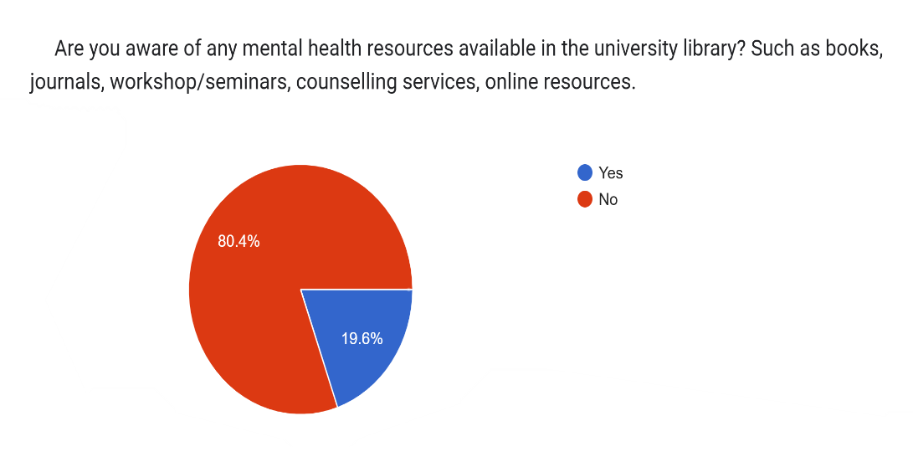
Figure 3: Showing the students' usage frequency and percentages of the library's mental health resources
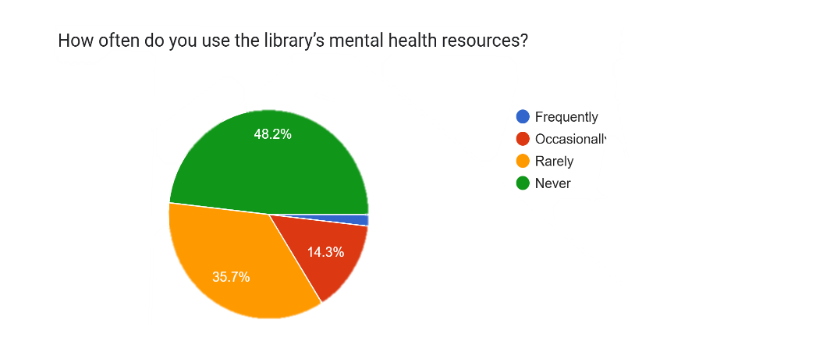
Figure 4: Showing the percentages of mental health resource types used by students.

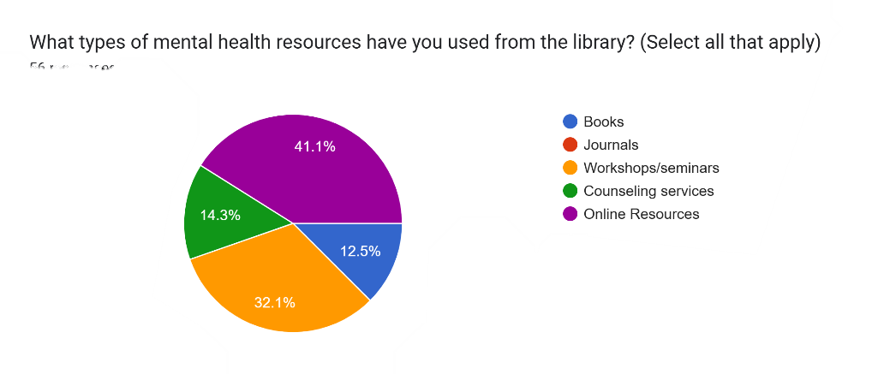

Figure 5: Showing percentages of the library’s mental health resource effectiveness
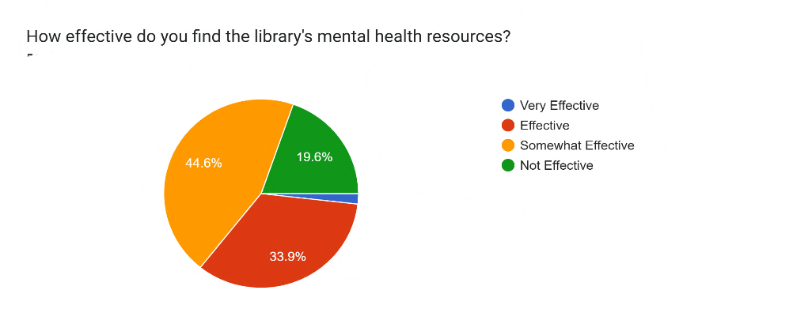
Research question 3: Impact of Library-Supported Mental Health Literacy Initiatives on Chukwuemeka Odumegwu Ojukwu University Students.
Figure 6 below shows the percentage of the impact of library-supported mental health literacy.
In Figure 6, 28(50%) of the students of Chukwuemeka Odumegwu Ojukwu University indicated that the library-supported mental health literacy initiative has had a positive impact on them. That being said, 9(16.1%) students in figure 7 indicated that such an initiative had a significant improvement on their well-being. While 14(25%) of the students indicated that they experienced moderate improvement and 16(28.6%) students indicated slight improvement on their well-being. Furthermore, in Figure 7, 17(30.4%) students noted that such initiatives have no impact on their mental well-being. Figure 8, shows that 38 students (67.9%) exhibit a strong level of confidence in topics relating to mental health, having engaged with library resources on mental health. However, 18 students (32.1%) were in opposition to discussing mental health.
Figure 6: The frequency and percentage of positive impact on students' understanding of mental health.
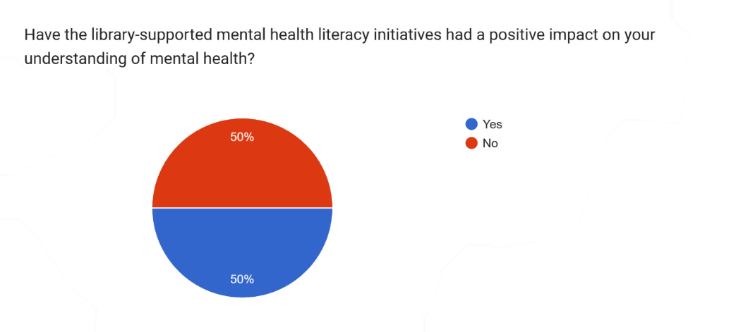

Figure 7: Percentages of impact on mental well-being
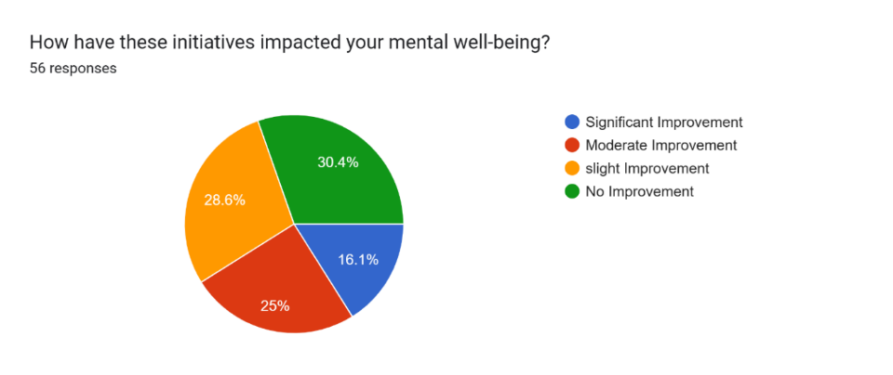
Figure 8: Percentages of students confident in discussing mental health topics
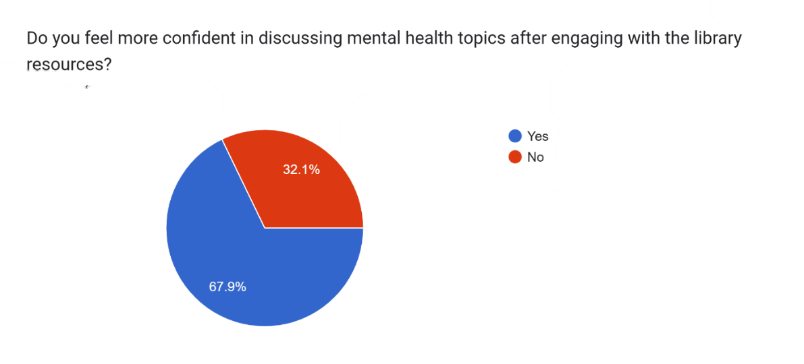
Research Question 4: Is there a relationship between library-supported mental health literacy and academic performance?
In Figure 9, below, we can observe that 49 students (87.5%) indicated that improved mental health literacy has a great relationship or impact on their academic studies, while only 7 students (12.5%) indicated that improved mental health literacy has no impacted on their educational performance. This impact on student's academic performance is properly shown in Figure 10, , where 40 students (71.4%) accepted that mental health literacy helped for better concentration, and 42 Students (75%) accepted that mental health literacy contributed to reducing stress. Furthermore, 36 students (64.3%) answered that mental health literacy has been of help in enhancing their problem-solving skills, and 18 students (32.1%) pointed out that it helped them with improved time management.

Figure 9: The frequency and percentages of students who believe that improved mental health literacy has a positive impact on academic performance
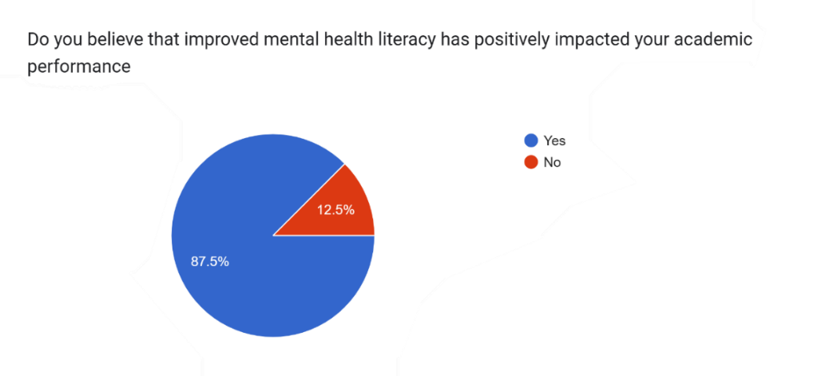
Figure 10: The frequency and percentage of students’ mental health literacy has with relation to students’ academic performance.
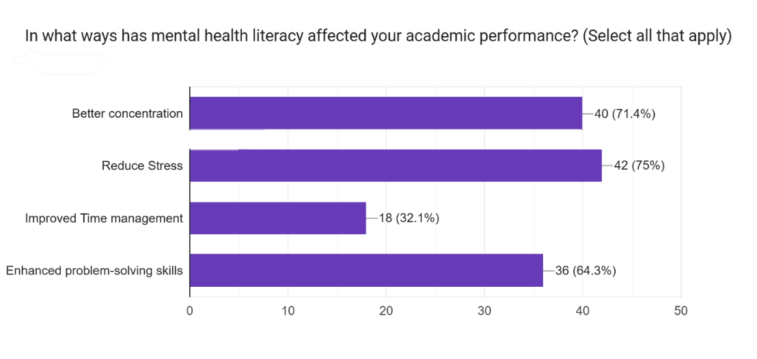

Research Question 5: What are the best practices and recommendations for libraries to support mental health literacy?
In Figures 12 and 13, the researcher noticed that as part of best practices, 49 students (87.5%) suggested that there should be more mental health workshops and seminars, while 42 students (75%) recommended that the library should acquire mental health topics on anxiety and stress management. In Figures 12 and 13, 39 students (69.6%) suggested that there should be increased availability of mental health materials. In addition, 47 students (83.9%) recommended that resource materials on depression should be seen in the library. Furthermore, 38 students (67.9%) in Figure 12, added that the library should collaborate with mental health professionals. In Figure 13, 42 students (75%) asked that the library should have specific mental health material, like students coping with academic pressure. Finally, in Figure 12, 36 students (64.3%) said that, as best practice, the library needs enhanced online resources. In Figure 13, 28 students (50%) recommended that the library should have a topic on how the students can build resilience to help them health-wise.
Figure 11: Frequency and percentage of best practices to in the library in supporting mental health literacy.
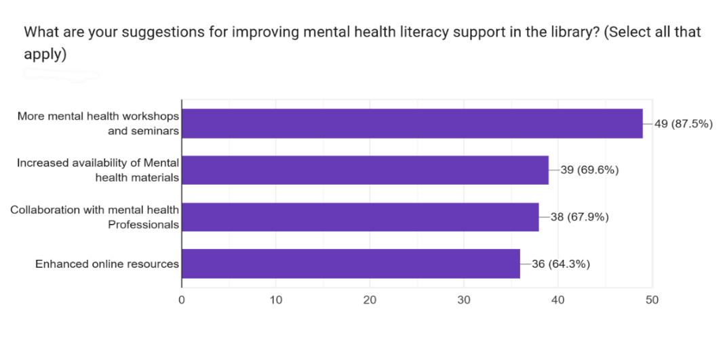
Figure 12: The frequency and percentage of recommendations for libraries to support mental health literacy
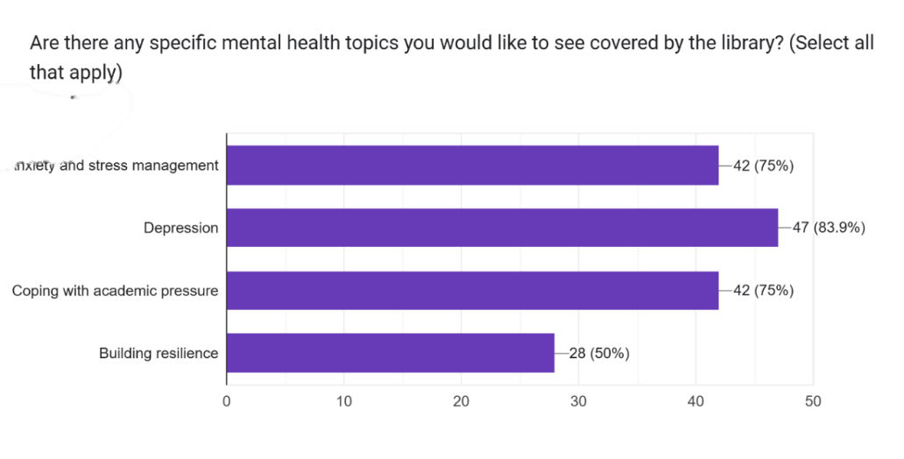

DISCUSSION OF FINDINGS
The study examined the role of libraries in supporting mental health literacy among students of Chukwuemeka Odumegwu Ojukwu University, Igbariam campus.
The findings from the study revealed major gaps in students’ mental health literacy. The most pressing gap was the lack of access to mental health services (71.4%), which was followed by stigma (69.6%), lack of awareness (69.6%) and then insufficient resources (57.1%). This shows that while students struggle with stress, anxiety, and depression, they also face barriers in accessing help, stigma and inadequate library resources. This supports Masara and Zirima (2024) that talked about the gap in mental health literacy among university students.
In current roles of the library, most students (80.4%) were unaware of existing library mental health resources. Consequently, the usage of library’s mental health resources turned out low, with many rarely or never used. It was seen that most students preferred online resources (41.1%) and face-to-face seminars (32.1%) more than physical books. This also suggests that although the library provides some sort of support, awareness, visibility, and accessibility remained low. Libraries encourage positive interaction through group activities such as book clubs and collaborative learning. Encouraging reading for pleasure and emotional growth, granting access to storybooks that build emotional literacy, empathy self-awareness reducing stigma and creating a safe space for students to discuss mental health which is line with Nance (2022)
The impact of library-supported initiatives showed that half of the respondents (50%) agreed that library mental health initiatives has positively impacted them, with improvements in their confidence (67.9%) and mental well-being. However, 30.4% indicated that there is no impact in their well-being, showing that the current interventions are not reaching all students effectively.
In using a correlational research design to examine the relationship between mental health literacy and academic performance, it was established that 87.5% of students reported that improved mental health literacy positively influenced academic performance. Specifically, it enhanced their concentration (71.4%), reduced stress (75%), improved problem-solving skills (64.3%), and supported time management (32.1%). This suggests that with improved mental health literacy, tends to better academic performance. This highlights the essential role of mental health literacy in academic success. This is in line with Wallin et al (2019) that an improved mental health literacy fosters better focus, motivation, stress management and higher academic performance.
Students suggested there is need for more workshops (87.5%), acquisition of resources on stress, anxiety, and depression (75–83.9%), collaborations with mental health professionals (67.9%), and enhanced online resources (64.3%). These all align with global best practices for library-supported mental health initiatives, which supports Stringer (2020) assertion on libraries collaborating with health professional to organise workshops and counselling sessions.

CONCLUSION
Libraries play a crucial role in supporting student mental health. This study reinforces existing research by other scholars showing that when libraries offer mental health literacy programs, safe spaces, and relevant resources, students benefit psychologically and academically. Implementing the recommended best practices will ensure that Chukwuemeka Odumegwu Ojukwu University’s library effectively supports student well-being and academic success.
RECOMMENDATIONS
- The library should acquire and make available print and digital materials on mental health, with a focus on stress, anxiety, depression, and coping strategies for academic pressure.
- There is need for the library to partner with counselling units, psychologists, and health professionals to organize regular seminars, training, and awareness programs. create stronger visibility for its mental health resources.
- Libraries should develop safe zones for quiet reflection, meditation, and relaxation activities to help reduce stress and foster well-being.
- It is necessary that librarians should undergo mental health first aid training for them to identify and support students in need of help.
- It is important that libraries provide access to mental health apps, podcasts, and online guides, as students showed preference for digital engagement.
- The library should establish mechanisms to assess the effectiveness of initiatives and gather feedback from students to improve library’s services.

REFERENCES
Chung, E.Y. & Tse, T.T. (2022). Effect of human library intervention on mental health literacy: A multigroup pretest–posttest study. BMC Psychiatry, 22(1), 73. Available from: https://doi.org/10.1186/s12888-022-03725-5
Jorm, A.F., Korten, A.E., Jacomb, P.A., Christensen, H., Rodgers, B. and Pollitt, P. (1997, February 17). Mental health literacy: A survey of the public's ability to recognise mental disorders and their beliefs about the effectiveness of treatment. Medical Journal of Australia, 166, 182-186. https://doi.org/https://doi.org/10.5694/j.1326-5377.1997.tb140071.x
Masara, T & Herbert Zirima. (2024, July 3). Retrieved from https://rsisinternational.org/journals/ijriss/articles/levels-of-mental-health-literacy-amongst-university-students-findings-from-a-university-in-masvingo-province-zimbabwe/
Merga, M. (2020). How can school libraries support student wellbeing? Evidence and lmplications for further research. Journal of Library Administration, 60(6), 660-673. https://doi.org/https://doi.org/10.1080/01930826.2020.1773718
Muslić,L, Burić,D.J, Markelić,M & Milanovic S.M. (2021, January). Mental health literacy. Retrieved from https://www.researchgate.net/publication/348311971
Nance, M. (2022). Playing for keeps: How academic libraries are priortizing student mental health and well-being through play. the Journal of play in Adulthood, 4(2), 162-176. https://doi.org/https://doi.org/10.5920/jpa.1026
National Association of School Psychologists. (2020). Mental health and academic achievement: Research summary. Bethesda, MD. Retrieved from https://www.nasponline.org/Documents/Research%20and%20Policy/Research%20Center/MentalHealthAcademicAchievement_2020.pdf
Stringer, H. (2020). Libraries as mental health hubs: Across the United States, libraries are striving to offer visitors mental health supports. Retrieved from https://www.apa.org/monitor/2020/2020-04-monitor.pdf
Wallin, A. S., Koupil I, Gustafsson JE, Zammit S, Allebeck P, Falkstedt D. (2019). Academic performance, externalizing disorders and depression: Soc Psychiatry Psychiatr Epidemiol, 977-986. https://doi.org/10.1007/s00127-019-01668-z.

